INVITATION TO TENDER FOR THE PROVISION OF RESEARCH

This document should be completed and returned in accordance with the Instructions to Tenderers contained herein
Tender to be submitted by: | Monday 29 August 2022; 17:00
To: | Sara Harris  Health and Care Professions Council  184 Kennington Park Road  London  SE11 4BU
E-mail address: | sara.harris@hcpc-uk.org  Procurement@hcpc-uk.org

CONTENTS

INFORMATION AND INSTRUCTIONS FOR TENDERERS | 3
- The Health and Care Professions Council (HCPC) | 3
- Background to the requirement | 3
- Tender return instructions | 4
- Contract terms and conditions | 4
- Acceptance of tenders | 5
- Quantities and scope | 5
- Further information | 5
- Contract period | 5
- Pricing | 5
- Evaluation | 6
- Timetable | 7
- Prevention of corruption | 7
- Freedom of information | 7
SPECIFICATION | 9
- Purpose | 10
- Quality | 11
- Timescales and deadlines | 12
- Cost | 13
EVALUATION CRITERIA | 14
- Stage 1 | 14
- Stage 3 | 14
- Stage 3 | 14
INFORMATION TO BE PROVIDED BY TENDERERS | 15
- Full name, address | 15
- Main contact | 15
- Current legal status of the Tenderer | 15
- Insurance | 15
- Equality and diversity | 16
- How we meet your specification | 17
FORM OF TENDER | 18
APPENDIX 1 – NEW GRADUATE SURVEY HIGHLIGHTS REPORT | 20

INFORMATION AND INSTRUCTIONS FOR TENDERERS

- The Health and Care Professions Council (HCPC)

  - The Health and Care Professions Council is a ‘body corporate’. We are a public body but we are not part of the Department of Health or the NHS in England, Northern Ireland, Scotland or Wales. We were set up on the 1 April 2002 by the Health and Social Work Professions Order 2001 (the Order), and replaced the Council of Professions Supplementary to Medicine.

  - We are one of ten UK statutory regulators of health and social care professionals. We were established to protect the public. To do this, we keep a register of professionals who meet our standards for their training, professional skills, behaviour and health, and we take action against those who do not meet the standards we set or who use a protected title illegally. As of 1 December 2021 we regulate approximately 296,000 individuals. These are known as “registrants” and are members of the 15 professions regulated by the HCPC.

  - We are an independent, self-funding organisation. All of our operational costs are funded by fees from registrants. Those fees are set out in the Health and Care Professions Council (Registration and Fees) Rules 2003 and any fee increases are subject to consultation and must be approved by the Privy Council.

  - Our offices are in London located at 184 Kennington Park Road.

  - Further details on the HCPC may be found on our website www.hcpc-uk.org.

- Background to the requirement

  - This is a new piece of standalone research.

  - In 2021 the HCPC ran a survey of new graduates which invited them to respond to a series of questions with a rating between strongly agree – strongly disagree (see Appendix 1). While the overall results are positive, there are limitations to the inferences we can make from this survey due to a small sample size (approximately 7% response rate) so we are keen to use this research commission to build on this but to take a wider, qualitative approach.

  - The primary research question is ‘how well are newly qualified HCPC registrants prepared for practice?’. As part of this we would like to understand:

    - whether there are any differences in the level of preparedness for newly qualified HCPC registrants who have one or more protected characteristic, and what causes those differences;

    - what support exists for newly qualified registrants, and whether additional support may be required, to provide for their transition from graduate to autonomous practitioner; and

    - whether different support might be needed for newly qualified HCPC registrants who have one or more protected characteristics.

  - We know that the coronavirus pandemic has impacted on the delivery of education and training for newly qualified HCPC registrants’, and while it is not the main focus of this research, we are keen to understand how this may have influenced registrants’ preparedness for practice.

  - This work forms part of a wider HCPC ambition to support registrants throughout their careers by understanding what causes less favourable outcomes and what action we might take to reduce these outcomes. It is likely that this research will feed into other ongoing programmes of work, such as work to develop guidance principles for preceptorship, and programmes of engagement for employers. Further information is detailed at the specification section of this document found at Page 9.

- Tender return instructions

  - Tenderers are required to complete and provide all information required by the HCPC in accordance with this Invitation to Tender (ITT). Failure to comply with these Instructions to Tender may lead the HCPC to reject a tender response.

  - Tenderers are requested to submit one copy of their tender electronically, via email with the subject heading “Policy research – Preparedness for Practice” to:

sara.harris@hcpc-uk.org
Procurement@hcpc-uk.org

Documents should be in a format that is compatible with Microsoft Office.

  - The tender is to be returned by no later than 29 August 2022; 17:00 (‘the Deadline’). The Health and Care Professions Council (HCPC) reserves the right to extend the Deadline. Any extension will apply to all tenderers. The HCPC reserves the right to reject any responses received after the Deadline.

  - It is each tenderer’s responsibility to ensure that their tender is emailed to the correct email address by the Deadline.

  - The HCPC reserves the right at any time to issue further supplementary instructions and updates and amendments to the instructions and information contained in this Invitation to Tender as it shall in its absolute discretion think fit.

  - The HCPC will not be responsible for the costs or expenses of any Tenderer in relation to any matter referred to in this Invitation to Tender howsoever incurred.

- Contract terms and conditions

4.1 In submitting a response to this ITT you offer to be bound by all the provisions of this ITT.
- Acceptance of tenders

  - The HCPC does not bind itself to accept the lowest or any tender.

  - The HCPC reserves the right to accept the whole or any part of any tender.

  - The tender is to remain open for acceptance by HCPC for a minimum period of 60 days from the Deadline.

- Quantities and scope

  - The quantities and scope of services set out in the Specification below are an estimate of the HCPC’s requirements at the time of producing this ITT. The information provided is to the best of our knowledge accurate at the time of issuing the ITT but circumstances may change over the contract duration.

  - Tenderers must form their own opinions, making such investigations and taking such advice (including professional advice) as is appropriate without reliance upon any opinion or other information provided by the HCPC or their advisers and representatives. Tenderers should notify the HCPC promptly of any perceived ambiguity, inconsistency or omission in this ITT, any of its associated documents and/or any other information issued to them during the procurement process.

- Further information

  - All requests for further information or clarification of the HCPC’s requirements in relation to this ITT must be addressed to:

sara.harris@hcpc-uk.org
Procurement@hcps-uk.org

  - The closing date for any further questions/clarification will be 15 August 2022; 17:00.

  - The HCPC reserves the right to issue the response to any clarification request made to all tenderers unless it is expressly required to be kept confidential at the time the request is made.

  - If the HCPC considers that the contents of the request should not be kept confidential, it will inform the requester and the requester will have the opportunity to withdraw the request.

- Contract period

  - The Contract will run for a period of 12 months commencing on [date tbc].

- Pricing

  - The Tenderer shall price all items. A budget of c.£52,000.00 (excl. VAT) is available for this work (depending on the scope of research).

  - The rates stated should exclude VAT which shall be charged at the prevailing rate, if applicable. No other costs will be accepted other than those in the Pricing Schedule.

- Evaluation

  - Tenders will be evaluated using the following criteria which have been set out in more detail under Specification:

Evaluation criteria | Weighting (%)
- Understanding of the role of the HCPC as a regulator  - Understanding of the research aims  - An appropriate methodology which is consistent with the research aims  - Research team have proven experience and expertise in undertaking research of a similar nature  - Understanding of the EDI issues relevant to the research project  - Proposal demonstrates the involvement of an appropriate range of stakeholders  - Proposal demonstrates a clear commitment and ability to deliver the research on time to an appropriately high standard  - Arrangements for research governance | 70%
- Value for money | 30%
Total | 100%

- Timetable

  - The indicative dates for the remainder of the procurement are set out in the table below. These are for guidance only and are subject to change at the sole discretion of the HCPC.

Activity | Expected date
ITT document issued to potential tenderers | 28/07/2022
Closing date for tenderer clarification questions | 15/08/2022; 17:00
Responses to all tenderer clarification questions | 18/08/2022; 12:00
Tender closing date | 29/08/2022; 17:00
Stages 1 and 2 evaluations completed and tenderers notified of outcome | w/c 29/08/2022
Shortlisted tenderers make presentations to panel as part of Stage 3 evaluation [note: this may not be necessary] | w/c 03/09/2022
Stage 3 evaluation completed and tenderers notified of outcome [only in cases where Stage 3 evaluation used] | w/c 08/09/2022
Contract award | 20/09/2022
Delivery of research starting from | tbc
Deadline for final report | tbc

- Prevention of corruption

  - Any attempt by any tenderer to influence inappropriately the contract award process in any way will result in that tender being disqualified. Any direct or indirect canvassing by any tenderer in relation to this procurement or any attempt to obtain information from any of the employees or agents of the HCPC concerning another tenderer may result in disqualification at the discretion of the HCPC.

  - The HCPC shall be entitled to cancel the Contract and recover from the Contractor the amount of any loss resulting from such cancellation should any tenderer, his servant or agent give or offer any gift or consideration whatsoever as an inducement or reward to any employee, agent or officer of the HCPC, which the tenderer may note will also constitute a criminal offence, punishable by imprisonment.

- Freedom of information

  - The Freedom of Information Act (‘FOIA’) applies to the HCPC. Any tenderer should be aware that the HCPC’s obligations and responsibilities under the FOIA to disclose, on written request, recorded information held by the HCPC. Information provided by a tenderer in connection with this ITT, or with any Contract which may be awarded as a result of this ITT, may therefore have to be disclosed by the HCPC in response to such a request, unless the HCPC decides that one of the statutory exemptions under the FOIA applies.

  - The HCPC may also decide to include certain information in the publication scheme which the HCPC maintains under the FOIA.

  - If a tenderer wishes to designate information supplied as confidential, it must provide clear and specific detail as to the precise elements which are confidential. For example, if a tenderer considers that any of the information included in their tender submission is commercially sensitive, it should identify it and explain (in broad terms) what harm may result from disclosure if a request is received, and the time period applicable to that sensitivity.

  - Tenderers should be aware that, even where they have indicated that information is commercially sensitive, the HCPC may still be required to disclose it under the FOIA if a request is received.

  - Tenderers should also note that the receipt of any material marked ‘confidential’ or equivalent by the HCPC should not be taken to mean that the HCPC accepts any duty of confidence by virtue of that marking.

SPECIFICATION

The deadline for proposals is 29 August 2022. We reserve the right to hold interviews as part of the tendering process and, if required, interviews will be held week commencing 3 September 2022.

Once appointed, we would seek to have an early meeting with the successful tenderer to confirm the final timeline for delivery.

About

The Health and Care Professions Council (HCPC) is an independent professional regulator set up to protect the public. We register the members of 15 different professions. We set and maintain standards which cover education and training, behaviour, professional skills and health; approve and monitor educational programmes which lead to registration; maintain a register of people that successfully pass those programmes; and take action if a registrant’s fitness to practise falls below our standards.

The HCPC identifies the threshold knowledge and abilities required for safe and effective practice in our Standards of Proficiency. Our Standards of Education and Training ensure that HCPC approved education programmes allow learners who successfully complete their programme to meet the Standard of Proficiency for their profession. Registration can be offered to those who successfully complete an approved programme. The ethical framework within which registrants must practice is set out in our Standards of conduct, performance and ethics.

At the point of registration, a registrant is expected to be able to meet all of the above mentioned standards, determine their own scope of practice and practise in a range of different settings, as part of a multidisciplinary teams and with diverse service users.

What is preparedness for practice?

We take preparedness for practice to mean the readiness of newly qualified HCPC registrants to demonstrate the conduct and competence requirements set out in the HCPC standards.

We recognise the first twelve months of practice will be a learning curve for registrants, but our standards are set at threshold level, and we expect all registrants to meet them, whatever the stage of their career.

What is preceptorship?

We take preceptorship to mean the period of transition for newly qualified practitioners to develop from student to autonomous practitioner. Preceptorship programmes usually occur within the workplace and vary in length, content and quality. We are undertaking a separate piece of work which aims to drive up consistency in preceptorship programmes.

Purpose

Some recent survey findings (see Appendix 1) identified potential gaps in the confidence new registrants have in their preparedness for practice and preceptorship support to help them transition from student to autonomous practitioner. While the overall response was positive, the survey had a 7% response rate and represents a graduate perspective only, so there are limitations to the inferences we can make from the data.

The intention of commissioning this research is to better understand how well newly qualified HCPC registrants, from each of the HCPC’s 15 professions, are prepared for practice. This research will help us to understand any areas where additional support may be needed and inform areas of our work such as:

- The development of resources for students and newly qualified registrants (learning materials, guidance documents, learning events, etc);

- Targeted engagement with education providers to enable them to address any areas of challenge through their education programmes;

- Engagement with employers and professional bodies to ensure additional support is provided where possible; and

- The forthcoming planned review of our Standards for Education and Training.

Scope of proposed research

The primary research question is ‘how well are newly qualified HCPC registrants prepared for practice?’.

As part of this we would like to understand:

    - whether there are any differences in the level of preparedness for newly qualified HCPC registrants who have one or more protected characteristic, and what causes those differences;

    - what support exists for newly qualified registrants, and whether additional support may be required, to provide for their transition from graduate to autonomous practitioner; and

    - whether different support might be needed for newly qualified HCPC registrants who have one or more protected characteristics.

Impact of the pandemic

We know that the Covid-19 pandemic has been disruptive to the delivery of education including access to placements and that this means students graduating during the pandemic years have faced new experiences and challenges with their education. We would like to gain an understanding of the impact that the pandemic may have had on the level of preparedness to practice of newly qualified HCPC registrants.

Target stakeholder groups for the research

We expect that all relevant stakeholders should be appropriately involved in the conduct of HCPC commissioned research. Proposals should clearly outline how the involvement of relevant stakeholders will be addressed during the research process.

We require the research team to have regard of the need to attract diverse views from across the UK, and from range of individuals with different backgrounds and characteristics.

We believe the views of the following groups will be important in establishing a clear understanding of newly qualified preparedness for practice:

- Practice placement supervisors who have supervised students on their first clinical placement;

- Newly qualified HCPC registrants who have been practicing between six to 18 months;

- Employers who have employed newly qualified HCPC registrants in the past year; and

- Service users who have experienced treatment by a newly qualified HCPC registrant in the past year.

The research team may also wish to seek the views of other stakeholders across all 4 UK nations, such as education providers, Chief Allied Health Professions Officers, Chief Scientific Officers, psychology profession leads, employers and professional bodies.

EDI data should be collected as part of this stakeholder engagement and reported (anonymously) as part of the results.

The tender proposal should include details of the proposed research methods to undertake this work.

Quality

Key performance indicators

Prior to the research starting there will be a meeting between the HCPC and research provider to confirm expectations and timelines.
At an early stage of the research the HCPC and research provider will meet again to discuss any challenges arising and consider whether any amendments are required to the timeline.
Once the data collection is complete, but prior to analysis commencing, the research provider will share an overview of findings and plans for analysis.
An interim report will be required mid-way through the project [at a time to be agreed by the HCPC and research provider]. Followed by a final report at the close of the project which should include:
- Information about the research methods adopted;
- Findings from the research; and
- A slide pack presenting the key findings.

The research team will also be expected to provide support in disseminating the research. This could involve presenting the findings to a range of different audiences, both within and outside of the HCPC; dates and duration to be agreed between the research team and HCPC.

How the contract will be managed

We expect the provider to report on a regular basis to the HCPC lead for the work about the progress of the research and particularly to ensure that the project stays on track in terms of achieving agreed milestones.

The provider will be required to develop a detailed project plan with key milestones from the outset of the commission. This will be agreed with the project lead and regularly updated as required for the duration of the research.

Sign off from the HCPC lead will be required at key stages which will be agreed with the appointed research team.

Understanding of HCPC’s environment and processes

We expect tenderers to understand the role of the HCPC as a regulator.

Timescales and deadlines

The below table indicates an estimated timeframe:

Activity | Expected date
ITT document issued to potential tenderers | 28/07/2022
Closing date for tenderer clarification questions | 15/08/2022; 17:00
Responses to all tenderer clarification questions | 18/08/2022; 12:00
Tender closing date | 29/08/2022; 17:00
Stages 1 and 2 evaluations completed and tenderers notified of outcome | w/c 29/08/2022
Shortlisted tenderers make presentations to panel as part of Stage 3 evaluation [note: this may not be necessary] | w/c 03/09/2022
Stage 3 evaluation completed and tenderers notified of outcome [only in cases where Stage 3 evaluation used] | w/c 08/09/2022
Contract award | 20/09/2022
Delivery of research starting from | tbc
Deadline for final report | tbc

Cost

A budget of c.£52,000 (excluding VAT) is available for this work (depending on the scope of research).

Payment Terms

Payment of the research budget will be made in instalments, with funds released at key stages of the Approved Project Schedule, subject to the research being completed to a satisfactorily high standard.

EVALUATION CRITERIA

Tenders will be evaluated by a panel which is likely to be made up of Emma Leary - Head of Policy, Standards and Strategic Relationships, Gareth Davies - Head of Insight & Analytics, Sara Harris – Policy Manager, Tarek Hussien – Procurement Manager but is subject to change. The panel will use the following criteria:

Stage 1
Pass/fail
- Is the tender compliant with the terms of the Invitation to Tender?

Stage 2, for tenders that pass stage 1
 | Weighting (%)
Quality | 70%
- Understanding of the role of the HCPC as a regulator
- Understanding of the research aims
- An appropriate methodology which is consistent with the research aims
- Research team have proven experience and expertise in undertaking research of a similar nature
- Understanding of the EDI issues relevant to the research project
- Proposal demonstrates the involvement of an appropriate range of stakeholders
- Proposal demonstrates a clear commitment and ability to deliver the research on time to an appropriately high standard
- Arrangements for research governance

Cost | 30%
- Cost breakdown (and value for money)

Total | 100%

Stage 3

The HCPC reserves the right to invite potential providers to present their proposals to the tender panel week commencing 3 September 2022. Presentations should last no more than fifteen minutes and will be followed by questions. The presentations will not be scored but will provide an opportunity for the tender panel to further clarify the proposals. If the HCPC determines this stage is necessary, providers will be notified week commencing 29 August 2022.

INFORMATION TO BE PROVIDED BY TENDERERS

- Full name & address of the Tenderer
Company name
Address
Town/City
Postcode
Website

- Main contact
Name
Position
Telephone Number
E-mail

- Current legal status of the Tenderer

Please tick one box
Partnership
Limited Company / PLC
Limited Liability Partnership

Company/LLP registered number
Other

Please provide details below
Consortium

Please outline below the proposed legal structure of the consortium including an organisation chart and a full description of each member’s role.
Details of “Other” legal status, or consortium legal structure etc, if applicable:

- Insurance
Please attach scan(s) provide evidence of the professional indemnity insurance held. The evidence should include the name of the insurers, policy number, expiry date and limits for any one incident and annual aggregate caps and the excesses under the policy.

- Equality and diversity

Please confirm that you support our ambitions as a public sector organisation bound by the Public Sector Equality Duty and have no discriminatory policies or procedures in place.
Do you provide training for your employees on equality and diversity?
In the last three years has any finding of unlawful discrimination in the employment field been made against you by an employment tribunal, an employment appeal tribunal, or any court or in comparable proceedings in any other jurisdiction?
If the answer to the previous question is yes, please provide details as to what steps have been taken by you as a result of that finding(s)

- How you meet our specification

Describe here or in attached documents how your research will meet our specification

- Pricing

Set out here or in attached documents your proposed prices/charges/fee for the research noting our requirements in the Costs section of the specification

- Please provide two references that we may contact to whom you have provided similar services

1st reference contact details

2nd reference contact details

FORM OF TENDER

To: The Health and Care Professions Council

Having examined the Terms and Conditions and the Specification for the provision of research I/We offer to carry out the whole of the said services in conformity with the said Terms and Conditions of Contract and associated work orders (to be detailed following selection of preferred supplier) and Specification.

I/We confirm that I am/we are not aware of any conflict of interest that would arise if I/we were to be successful in this tender.

The essence of selective tendering is that the client shall receive bona fide competitive tenders from all those tendering. In recognition of this principle, I/we certify that this is a bona fide tender, intended to be competitive, and that I/we have not fixed or adjusted the amount of the tender by or under or in accordance with any agreement or arrangement with any other person. I/We also certify that I/We have not done and will not do at any time before the hour and date specified for the return of this tender any of the following acts:-

a. communicating to a person other than the person calling for those tenders the amounts or approximate amount of the proposed tender, except where the disclosure, in confidence, of the approximate amount of the tender was necessary to obtain insurance premium quotations required for the preparation of the tender;

b. entering into any agreement or arrangement with any other person that he shall refrain from tendering or as to the amount of any tender to be submitted;

c. Offering or paying or giving or agreeing to pay or give any sum of money or valuable consideration directly or indirectly to any person for doing or having done or causing or having caused to be done in relation to any other tender or proposed tender for the said work any act or thing of the sort described above.

In this Form of Tender the word "person" includes any persons and any body or association, corporate or unincorporated; and "any agreement or arrangement" includes any such transaction, formal or informal, and whether legally binding or not.

Signature: Designation:

for and on behalf of:
Address:

Date: Tel. No

APPENDIX 1 - New Graduate Survey 2021 Highlights Report

Executive Summary

This paper presents highlights from our New Graduate Survey (2021). The survey was launched in September 2021, to seek the views of new graduates about their education and training programme, how this prepared them to practice, and the first year in employment. We intend to integrate insight into our education quality assurance activities and inform focus areas for our Policy and Professionalism and Upstream Regulation teams.

This report provides highlights key findings from the survey. Conclusions drawn from the data are indicative, but caution should be exercised due to the sampling framework adopted which was unstructured and non-random. Where relevant, we have picked out key learning where improvement and further exploration could be undertaken and will consider this through ongoing work.

Contents
Pre-registration preparation for practice 1
Preceptorship 2
The influence of service users 3
The quality of education and training – Interprofessional education 4
The quality of education and training – programme and staff interactions 5
The quality of education and training – academic learning 7
The quality of education and training – practice-based learning 8
Recommendation likelihood 9
Word Association Sentiment 10

Pre-registration preparation for practice
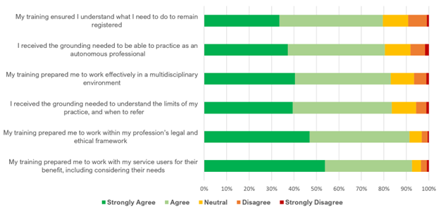
Figure 1 Preparedness for practice, statement agreement across all respondents (N=888)

Summary
Responses linked to feeling prepared to practice generally evoked high levels of agreement (80-92% agreed with statements consistently).

Statements such as ‘my training ensured I understand what I need to do to remain registered’ and ‘I received the grounding needed to be able to practise as an autonomous professional’ provoked the most dispute, but also equated to <10% of responses highlighting it as a minority opinion.

Profession specific findings
The following processions often responded with lower levels of agreement to the statements linked to preparedness for practice:
- Paramedics (68-87%)
- Occupational therapists (66-91%)

Recommendations
- Explore autonomy and limits of practice with providers delivering paramedic and occupational therapy training, to consider whether improved support may benefit learners in preparing for practice (Education)

Preceptorship
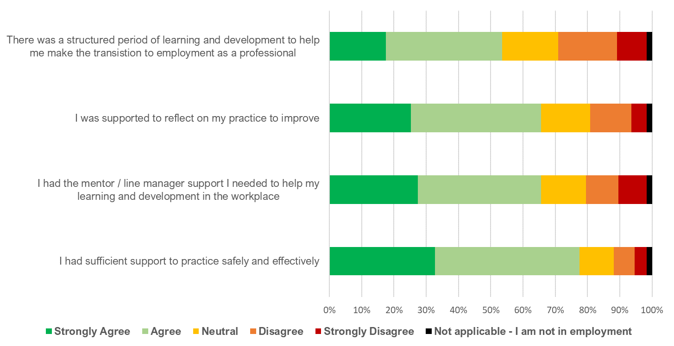
Figure 2 Preceptorship, statement agreement across all respondents (N=888)

Summary
Compared to preparedness for practice, preceptorship statements appeared to elicit a slightly lower level of agreement among respondents. Although agreement outweighed disagreement for all statements, agreement levels were highest in reference to having ‘sufficient support to practice safely and effectively’, and lowest for having had ‘…a structured period of learning and development to help me make the transition to employment as a professional’.

Profession specific findings
- Paramedics were noted to disagree more often than other respondents to the statements (28% average as opposed to 18% among all respondents)
- The following professions were more likely to agree with the statements (the following averages are compared with 66% for all respondents):
  - Hearing aid dispensers (average 95%), although this profession has a small sample size
  - Biomedical scientists (average 81%)
  - Practitioner psychologists (average 73%)
  - This may be caused by a higher percentage of employer-led routes within biomedical scientist and hearing aid dispenser training, which may lead to the transition to employment easier for new registrants for these professions

Recommendations
- Consider whether further support can be provided to Paramedic employers, to support new registrants in their first year of employment (Professionalism and Upstream Regulation)

The influence of service users
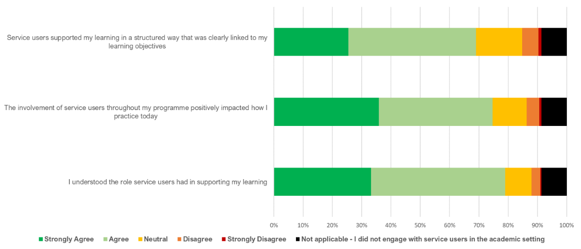
Figure 3 The influence of service users, statement agreement across all respondents (N=888)

Summary
Agreement outweighed disagreement across statements examining the influence of service users, overall presenting a positive picture:
- Overall, 79% of respondents ‘agreed/ strongly agreed’ that they understood the role that service users had in supporting their learning.
- Furthermore, 75% of respondents ‘agreed/strongly agreed’ that involvement of service users throughout their programme positively impacted how they practice today.
- Finally, 69% of respondents ‘agreed/strongly agreed’ that service users supported their learning in a structured way that was clearly linked to their learning objectives.

It is of note that almost 1 in 10 respondents (9%) reported that they had not engaged with service users in the academic setting. All providers must meet a specific standard requiring service user involvement, to become and remain approved, and we would expect this would usually include learners interacting with service users.

Profession specific findings
- Biomedical scientists reported the least agreement across statements linked to service users (average: 59% agreement as compared to the total 75% agreement), however this was not statistically significant (with the exception of the statement ‘I understood the role that service users had in supporting learning’). While not significant on the other statements, its position remained as ‘least agreeing’ of all professions across the statements
- Paramedics also demonstrated low levels of agreement (average: 68%)

Recommendations
- Explore how providers involve service users in their programmes, ensuring they see the benefit of direct service user / learner interaction, particularly focused around the biomedical scientist and paramedic professions (Education)

The quality of education and training – Interprofessional education
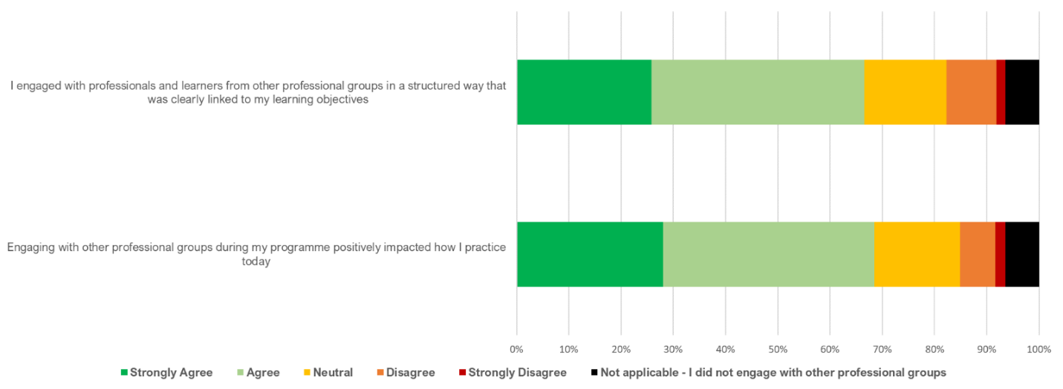
Figure 4 Quality of Education, All Respondents (N=888)

Summary
Agreement to interprofessional education statements outweighed disagreement (67-68%), but it was somewhat concerning to note 6% of respondents reporting they did not engage with other professional groups. Interprofessional education is an important requirement of all programmes HCPC approves. It relates to the interactions learners have with registered professionals and learners from other professional groups, with the aim of benefiting service users.

Profession specific findings
- Biomedical scientists reported the largest proportionate share of all professions for not engaging with other professional groups (32%)
- Physiotherapists were statistically more likely to agree that they had engaged with professionals and learners from other professional groups in a structured way that was clearly linked to learning objectives compared to other respondents (77%)
- Arts therapists were statistically more likely to agree that engagement with other professionals and learners had positively impacted how they practice today (85%)

Recommendations
- Explore this finding with education providers, including how they ensure learners recognise they are learning with and from other professionals for the benefit of service users (Education)

The quality of education and training – programme and staff interactions
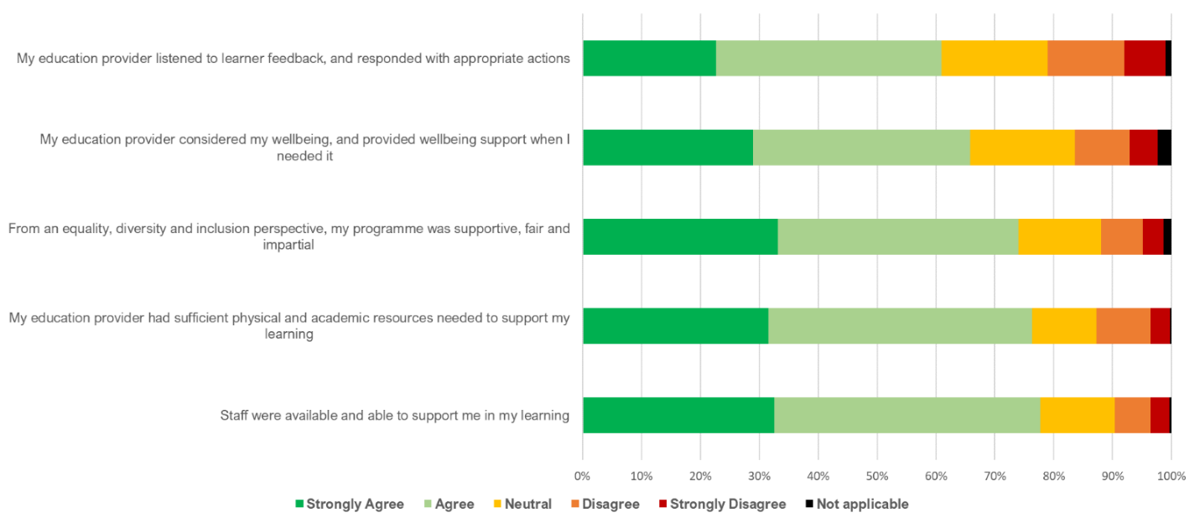
Figure 5 Quality of Education, All Respondents (N=888)

Summary
A positive picture was depicted by responses; with agreement outweighing disagreement consistently across statements. The statement evoking the most agreement was: “Staff were available and able to support me in my learning” (78% of all respondents agreed), while the statement resulting in the least agreement was: “My education provider listened to learner feedback and responded with appropriate actions” (20% of all respondents disagreed, 61% agreed).

Profession specific findings
- Arts therapists were significantly more likely to agree to that statement ‘staff were available and able to support students in their learning’ than other professions (97%).
- Paramedics were significantly more likely to disagree with the above statement (15%).
- The following professions showed higher agreement to the statement: ‘From an equality, diversity and inclusion perspective, my programme was supportive, fair and impartial’:
  - Operating department practitioners (88%)
  - Radiographers (86%)
  - Physiotherapists (84%)
- Arts therapists had significantly lower levels of agreement with the above statement (56%).
- Speech and Language Therapists were less agreeing than the average new graduate to the statement: My education provider considered my wellbeing and provided wellbeing support when I needed it (54% compared to 66% all respondents).
- The following professions were significantly less likely to agree to the statement ‘My education provider listened to learner feedback, and responded with appropriate actions’, than other professions:
  - Clinical Scientists (43%)
  - Paramedics (51%)

Recommendations
- Develop relevant portfolio areas, to embed findings to be reflected upon by education providers (Education)
- Use the findings from this section as a baseline for next year’s survey – and consider next year’s findings within the context of this baseline (Education / Insight and Analytics)
- Consider EDI findings in line with the EDI action plan, and take action as needed (Education)

The quality of education and training – academic learning
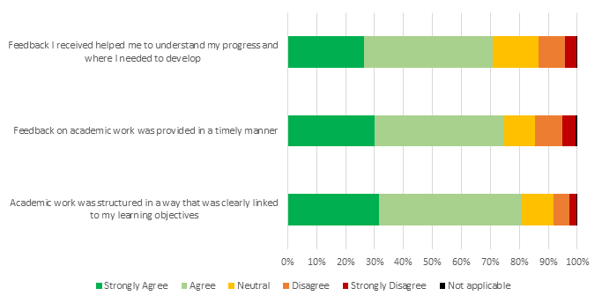
Figure 6 Quality of Education, All Respondents (N=888)

Summary
The results illustrate a high level of agreement. Academic work structure linking to learning objectives was the most widely agreed with statement, while statements linked to feedback provision were less well rated.

Profession specific findings
- Occupational therapists are less likely to agree that academic work was structured in a way that was clearly linked learning objectives (74% compared to 81% all respondents).
- The following professions were more likely to agree with the above statement:
  - Arts therapists (95%)
  - Practitioner psychologists (90%)
- The following professions were less likely to agree that feedback on academic work was provided in a timely manner (all respondents 75%)
  - Clinical scientists (45%)
  - Paramedics (65%)
- Clinical scientists were also less likely to agree that feedback received helped them to understand their progress and where they needed to develop (48% compared to 71% all respondents)
- The following professions were more likely to agree with this statement
  - Practitioner psychologists (80%)
  - Arts therapists (87%)

In relation to Clinical Scientists being less likely to agree with the statements in this section, most Clinical Scientists undertake a route to registration where the approved provider quality assures academic learning at several higher education institutions. This means we are one step further removed from the quality of academic learning than for many other training routes.

Recommendations
- Explore findings with Clinical Scientist providers, particularly focused on whether their own quality assurance processes / activities have picked up issues in this area, and if so, what actions they are taking (Education)

The quality of education and training – practice-based learning
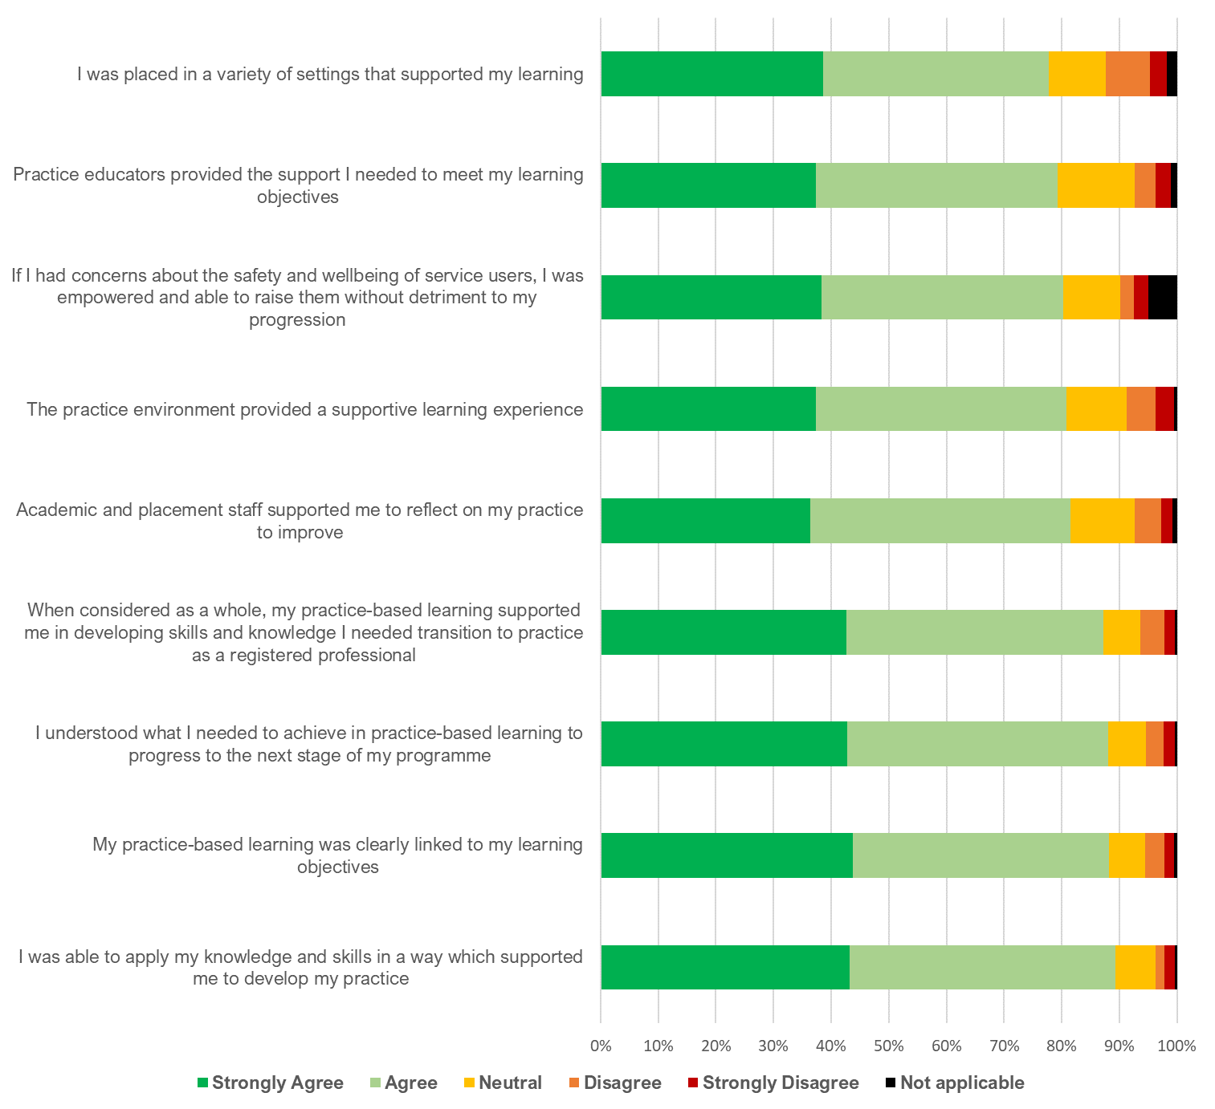
Figure 7 Quality of Education, All Respondents (N=888)

Summary
Agreement was consistently high across the statements, often nearly or over 80%. This is a positive result, showing registrants value practice-based learning elements of their programme, and they have the desired impact to support individuals to become autonomous professionals with a good grounding in clinical practice.

It is also positive to note that agreement was high for support-type statements, showing that practice educators are supporting learners well in practice settings.

Profession specific findings
- The following professions reported higher than average agreement on many practice-based learning statements (All respondents 84%)
  - Practitioner psychologists (88%)
  - Arts therapists (89%)
- The following professions reported lower than average agreement
  - Clinical scientists (76%)
  - Speech and language therapists (79%)
  - Paramedics (80%)

Recommendations
- Celebrate success with relevant stakeholder groups, providing specific data and information where this is useful to support messages (Education)

Recommendation likelihood
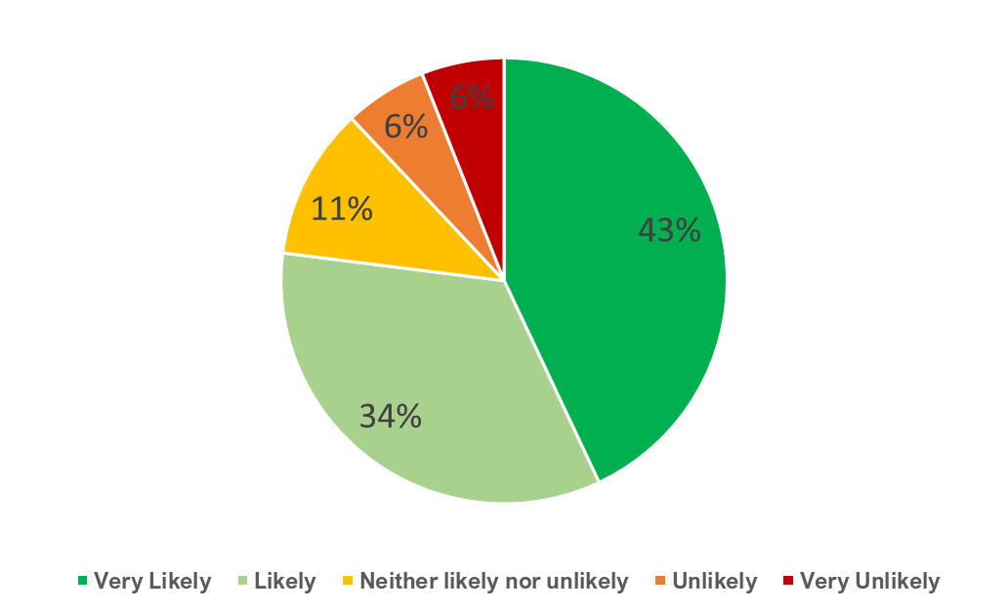
Figure 8 Recommendation Likelihood Rating, across all respondents (N=888)

Summary
New graduates were asked how likely they would be to recommend their programme or education provider to a friend or family member who was considering entering professional training. Overall, the response was very positive, with 77% reporting that they would be very likely/ likely to recommend.

Profession specific findings
- Paramedics are significantly less likely to report intention to recommend their programme (64% reported they would be very likely/likely to recommend))
- The following professions were significantly more likely than average to recommend:
  - Practitioner psychologists (87%)
  - Hearing aid dispensers (100%) (NB: The sample size for this group was small N=14)

Recommendations
- Use positive score as part of key messages in communicating findings of the survey (Education)

Word Association Sentiment
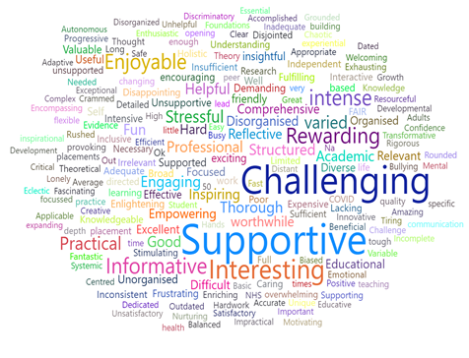
Figure 9 Words associated with Programme, All respondents (N=888)

Summary
New graduates were asked to provide three words which summarised their programme. ‘Supportive’, ‘challenging’ and ‘interesting’ were the most frequently quoted words respondents reported associating to their programme.

Words were also analysed through the lens of sentiment, with 59% of words being of positive sentiment, and 17% of negative sentiment. The remainders were ambiguous or neutral (e.g. words such as “Regulator”).

Profession specific findings
- Prosthetists / orthotists had the most positive profile of words (100% positive sentiment); however this also was a very small group of respondents (N=3) so this must be kept in mind in terms of generalisability
- The following professions had the largest proportion of words of negative sentiment:
  - Paramedics (27%)
  - Speech and language therapist (22%)
  - Dietitians (20%)

Recommendations
- Include three most frequent words when communicating findings from the survey (Education)

